Hiking
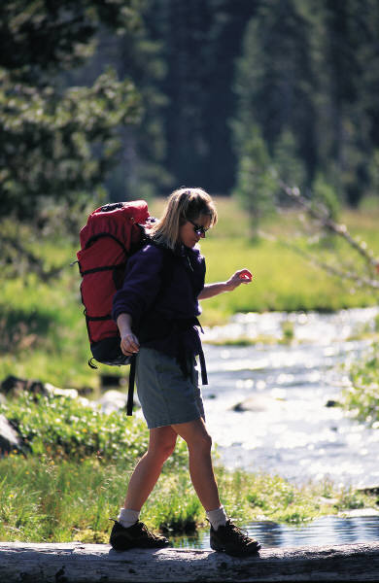
There is extensive hiking throughout the Florida District of the Gulf Islands National Seashore. A wide variety of habitats can be explored from beach to forest. You can walk the beautiful white sand beaches or take a stroll on one of the many trails through barrier islands, maritime forests or wetlands. Self-guided trails help hikers discover the park's natural resources.
For your safety there are a couple of things to remember. Florida has a temperate climate and it is not unusual for it to rain, so be prepared for a thunderstorm. If caught in an approaching lightning storm, lie flat in low-lying dunes. Also insects are more a problem in the summer then in the winter but always be prepared with a good insect repellent. Of course, sunburn is always best combated with sunscreen with a high SPF, hats and sunglasses. Closed signs are posted for dune preservation, restoration of the area or for nesting shorebirds.
There are many beautiful areas to sit and enjoy a picnic lunch as you hike. Drink plenty of water to avoid dehydration.
Have your camera, binoculars and field guide close at hand to identify the numerous plants and animals. There are wonderful views for sketching or painting.
Always use care when investigating under fallen trees or among dense foliage; some inhabitants may bite when surprised by a searching hand.
Remember Leave No Trace.

